**BridgePrep Academy of Village Green 2018-2019 Kindergarten Supply List**

* 1 Book Bag
* 1 School Agenda (Purchase at school)
* School Spirit Shirt (Purchase at school)
* 2 Reams of copy paper
* 2 Pack of sharpened pencils with erasers
* 2 boxes of 24 Crayola crayons
* 4 Elmer’s glue sticks
* 3 plastic folders with pockets and prongs

(Red, blue, yellow)

* Over the ear headphones
* 1 primary composition books (fully lined)
* 2 primary journal (picture space with lines on the bottom)
* 1 supply box
* 1 small dry erase board
* 1 pair of children’s blunt scissors
* 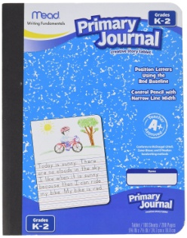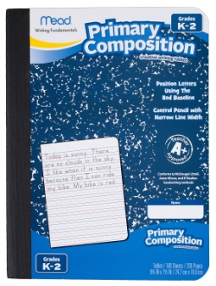1 pack of erasers
* 1 (12 oz) liquid hand soap (GIRLS)
* 1 Box of Ziploc bag gallon size (GIRLS)
* 1 tissue box (GIRLS)
* 1 box of Ziploc bags quart size (BOYS)
* 1 roll of paper towels (BOYS)
* 1 liquid hand sanitizer with pump (BOYS)
* 1 large container of Clorox or Lysol wipes
* 1 box of baby wipes

*Please check the supply list for Spanish as well.